# User Document

This system has been designed for One World Health and allows a user to add, edit and delete Stock as well as make sales and generate reports. When the user launches the system, they will see the menuBar at the top of the screen which is highlighted by the green box, this is used for most navigation in the programme.

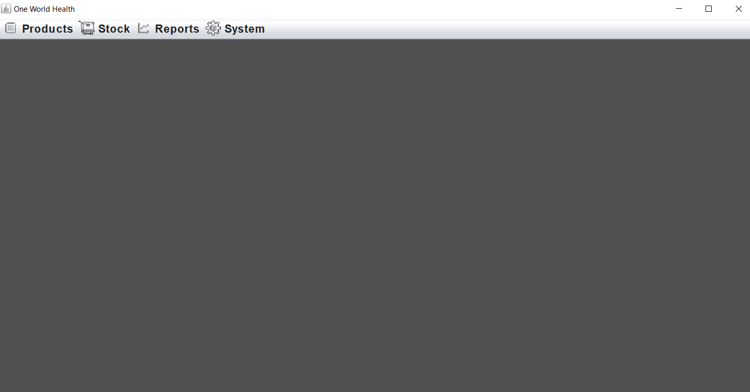

Clicking on each of the 4 menu items, Products, Stock, Reports and System, you will see some other options below those menu items.

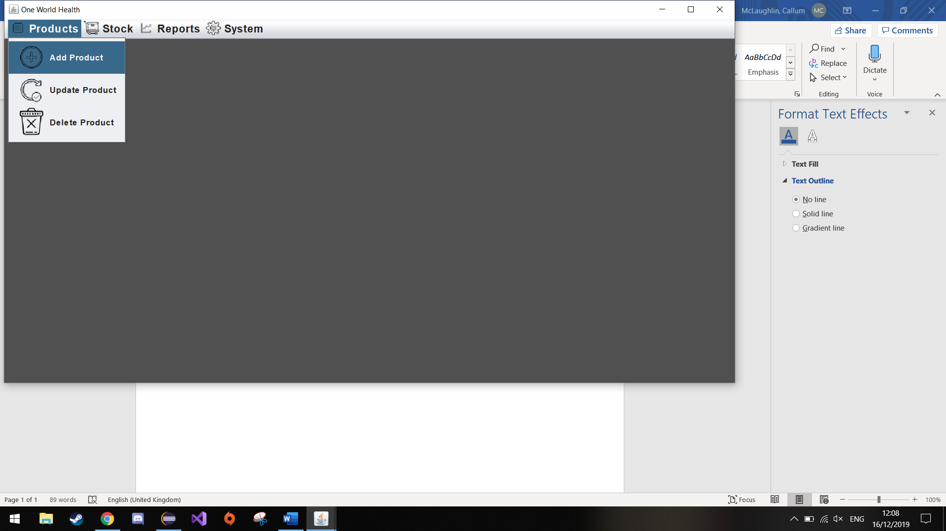

The products menu item contains 3 options, Add, Edit and delete which will allow the user to Add, Edit and delete Products to/from the system.

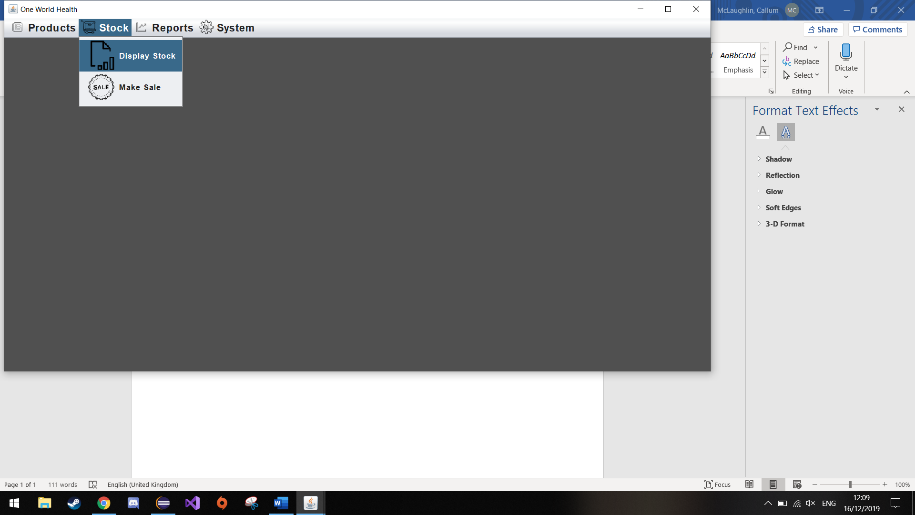

The Stock menu item allows the user to view all the stock that has been added to system and the user can also make sales which will update the total stock of each product.

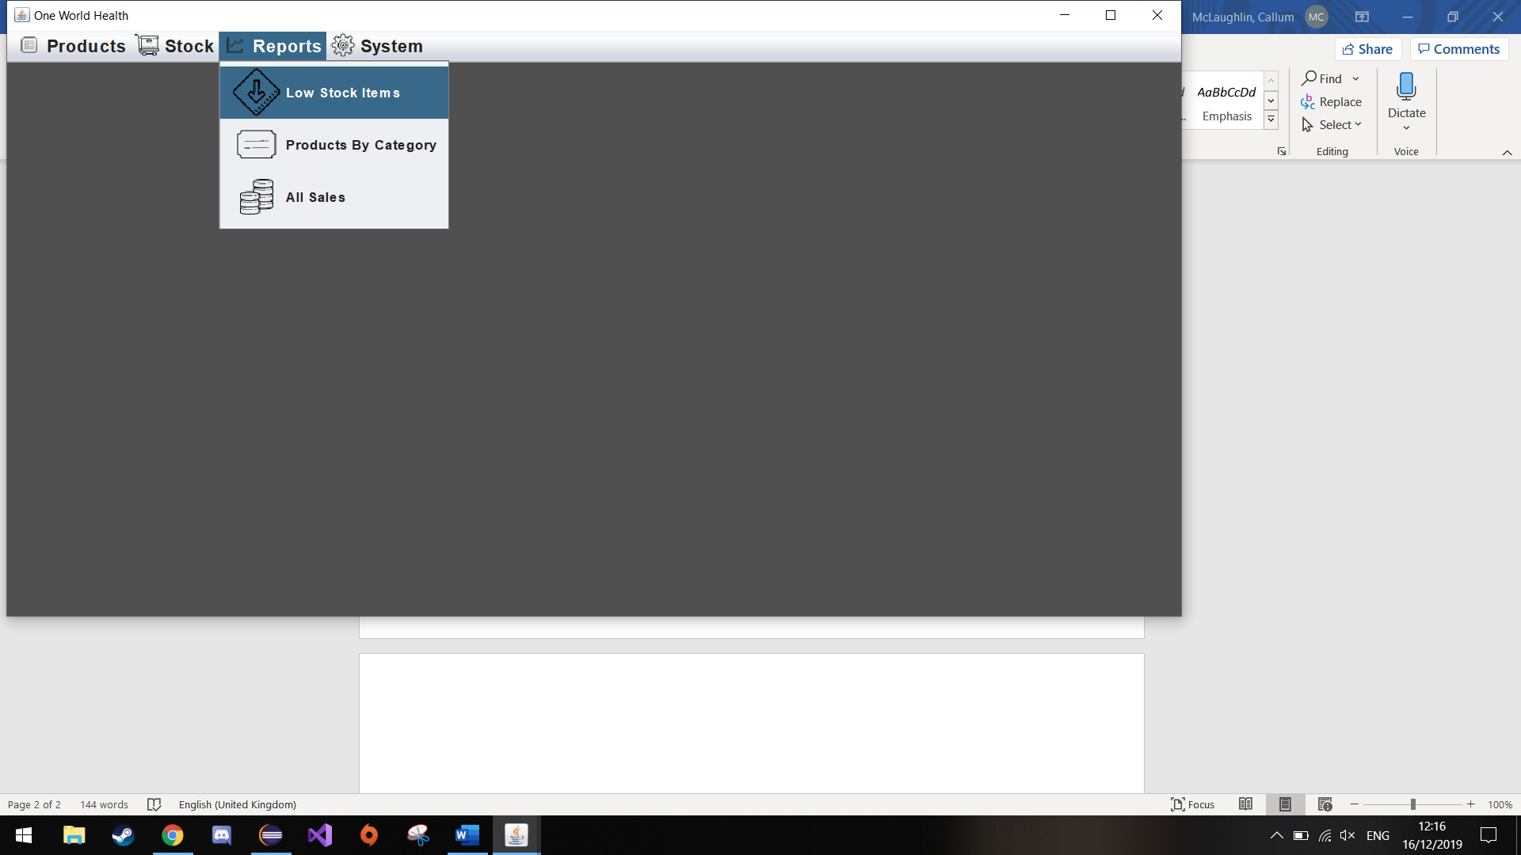

The reports menu allows the user to generate reports for Low Stock item, Products by Category and All Sales. When the user clicks on one of the reports, the report is written out to a file which is generated after the button is clicked and it also displays the report on screen.

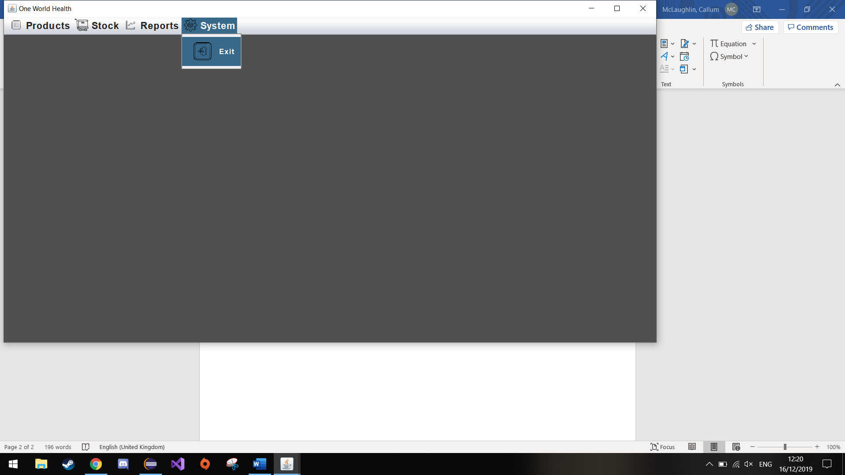

The System menu item will give the user the option to exit the system. When the exit button is clicked it will show a confirmation dialog prompting the user to conform whether they want to exit the system. This can be seen in the image below.

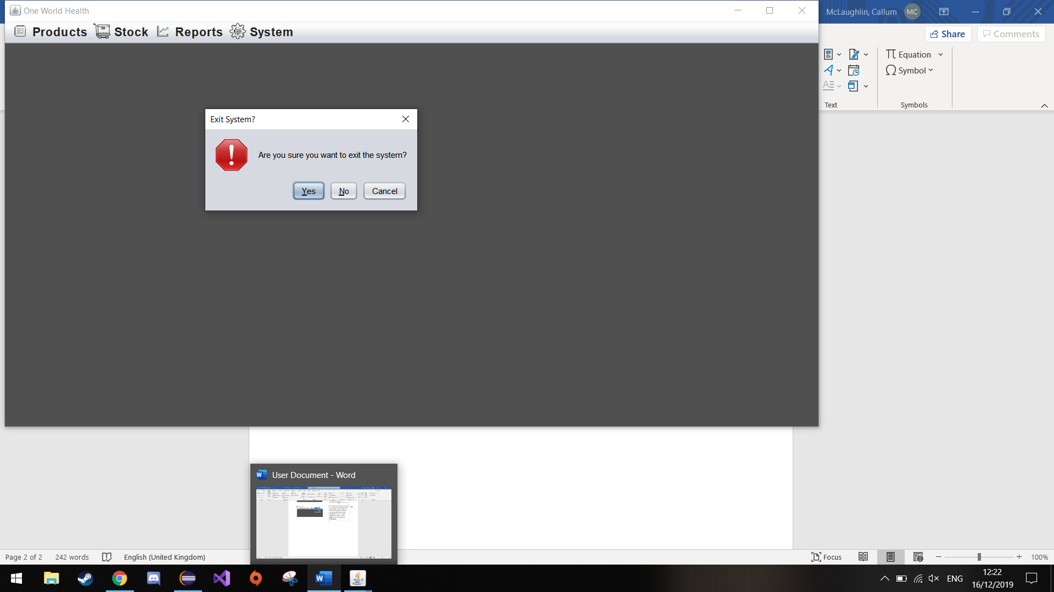

When the user clicks on the add option, they will be taken to a screen that will display 5 buttons, one for each of the different categories of products that can be added to the system. This is shown below:

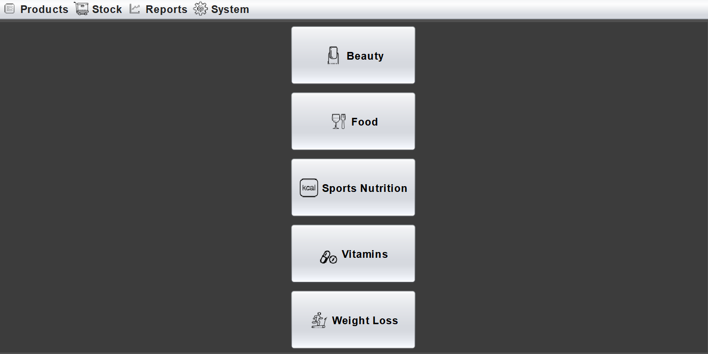

When the user clicks on one of the buttons it takes them to a screen which will be the same for each category button except for the products displayed on the right being from the relevant category. An example of the beauty screen is shown below:

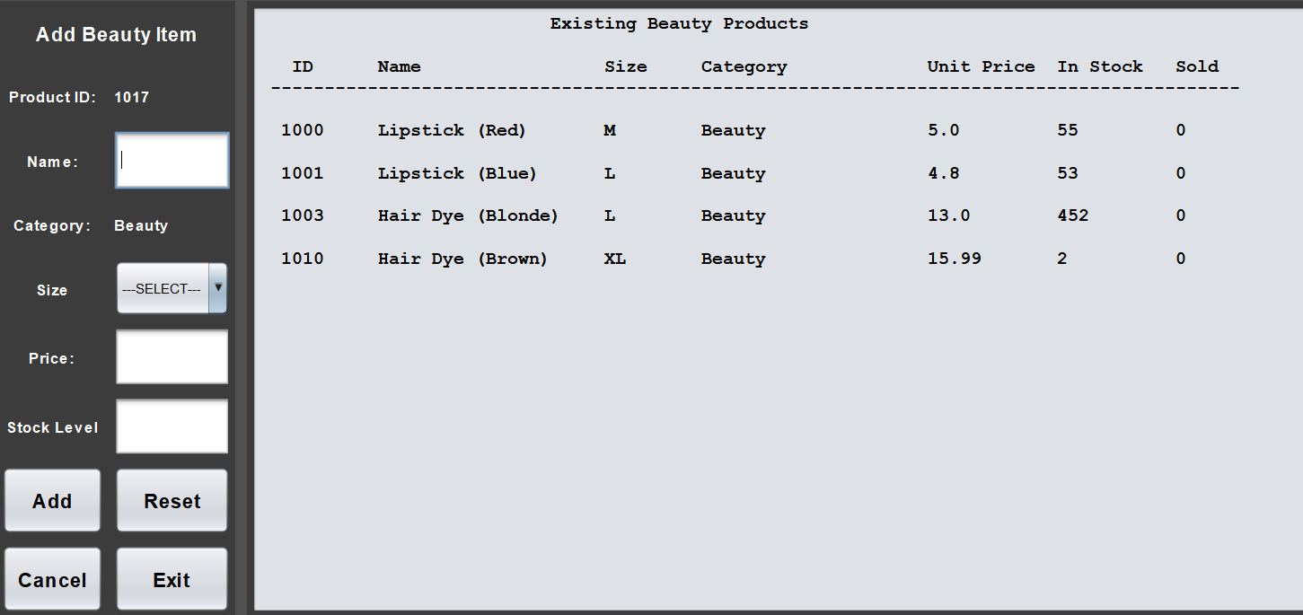

This screen shows the beauty products that have already been added to the system as well as the data entry fields that are required in order to add a product to the system. If the user enters invalid data for any number of the data entry fields, an error message will be displayed listing the specific errors. An example an error message that is displayed when the add button is clicked without entering any data is shown below:

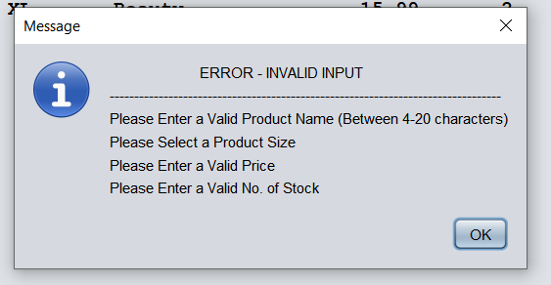

When the user clicks the reset button, all the data entry fields will be reset back to the default, text fields will be cleared, and the combo box will be reset to index 0. The Cancel button will return the user to the Add product – category selection screen. When the user clicks the exit button the same confirmation dialog will be shown as the previous exit option, which will ask the user to confirm if they want to exit the system.

When the user successfully adds a product, they screen will change to the list of products and will show the newly added product in the list.

If the user clicks on the edit option in the Products menu item, they will be taken to a new screen where they must enter the Product ID of the product they want to edit.

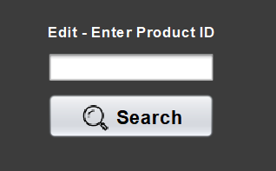

If the ID is valid it will show the product on screen with the fields filled with the data currently stored about that product, the user will be able to edit the fields. An image of this screen is shown below as well as an image of the edit search to the left:

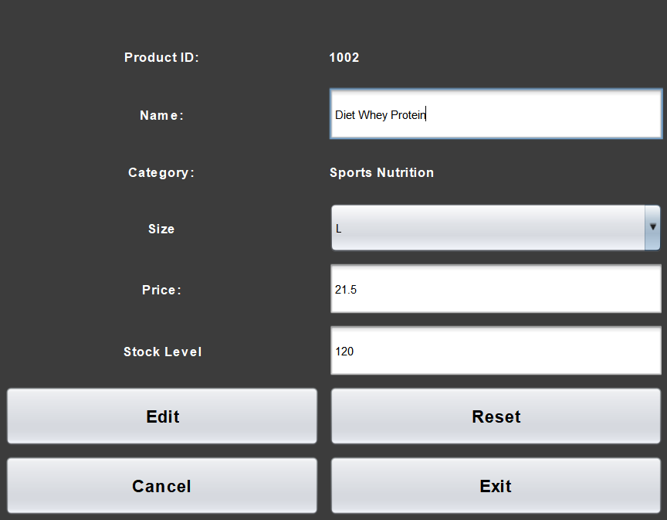

When the edit button is clicked the system will check if the data the user has entered is valid and if so it will commit the change, if not it will show an error message which is the exact same as the add screens error message. The other buttons, Reset, Cancel and exit all do the same as the add screens except for the cancel button which will return the user to the edit search screen.

The delete option on the Products menu item takes the user to a search screen which is the same as the edit search screen. If the user enters a valid ID a new screen will be shown with the details of that product but the fields will de disabled so the user cannot change them in the delete screen, they can only do this in the edit screen. This allows the user to view the details they are about to delete. If the Product ID is not valid and error message will be displayed the same as the edit search error message. This is shown below:

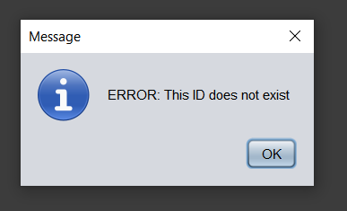

This is what the delete screen looks like after the user has entered a valid ID.

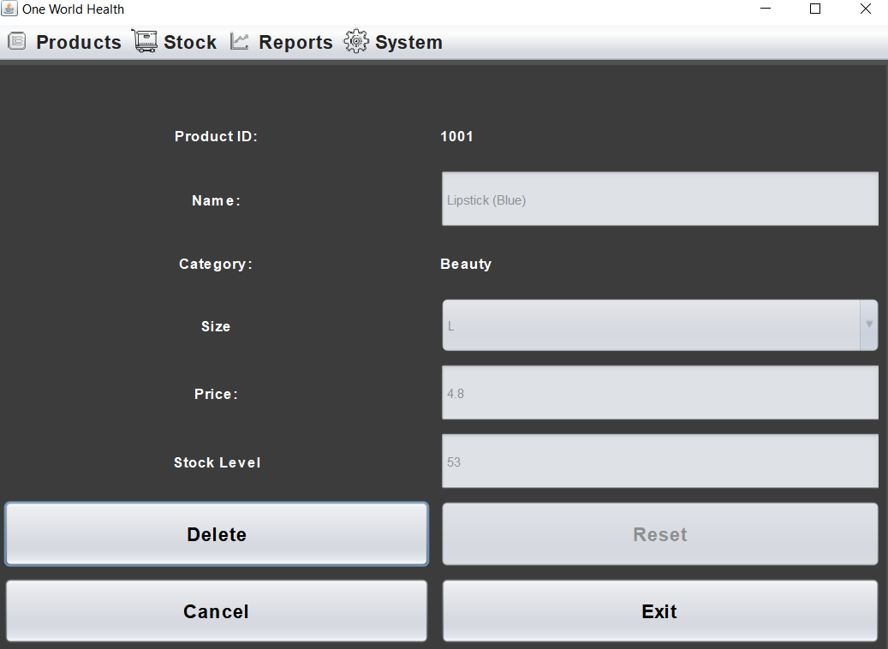

If the user then wants to delete the product, a confirmation dialog will be displayed on screen asking the user if they are sure they want to delete the product from the system. If they choose yes, the product will be removed from the system, if they choose no or cancel the system will return to the screen showing the details of the product but it will not remove the item from the system.

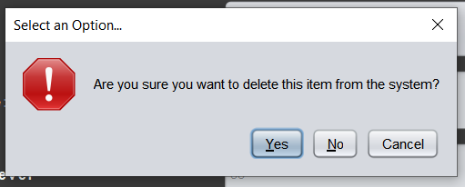

When the user clicks on the display stock option in the Stock menu item, it will display all stock on the system, an example is shown below:

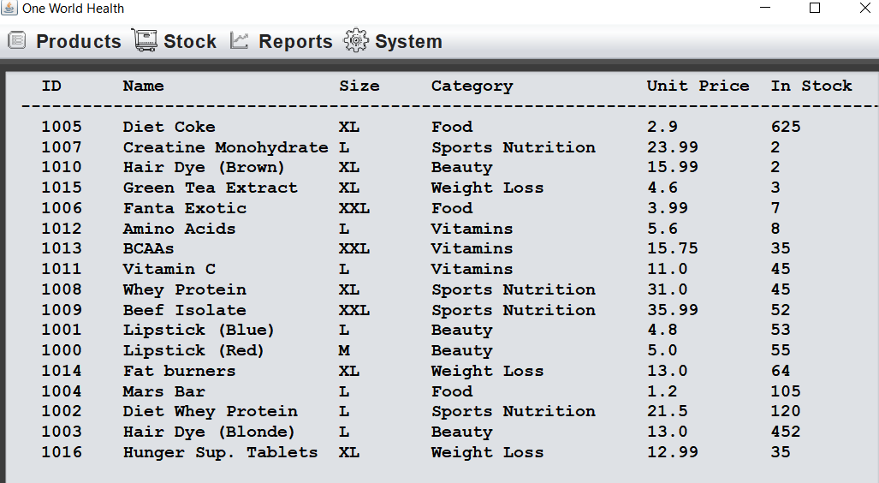

If the user clicks on the Make sale option under the stock menu item, they will be taken to the sale screen as shown below:

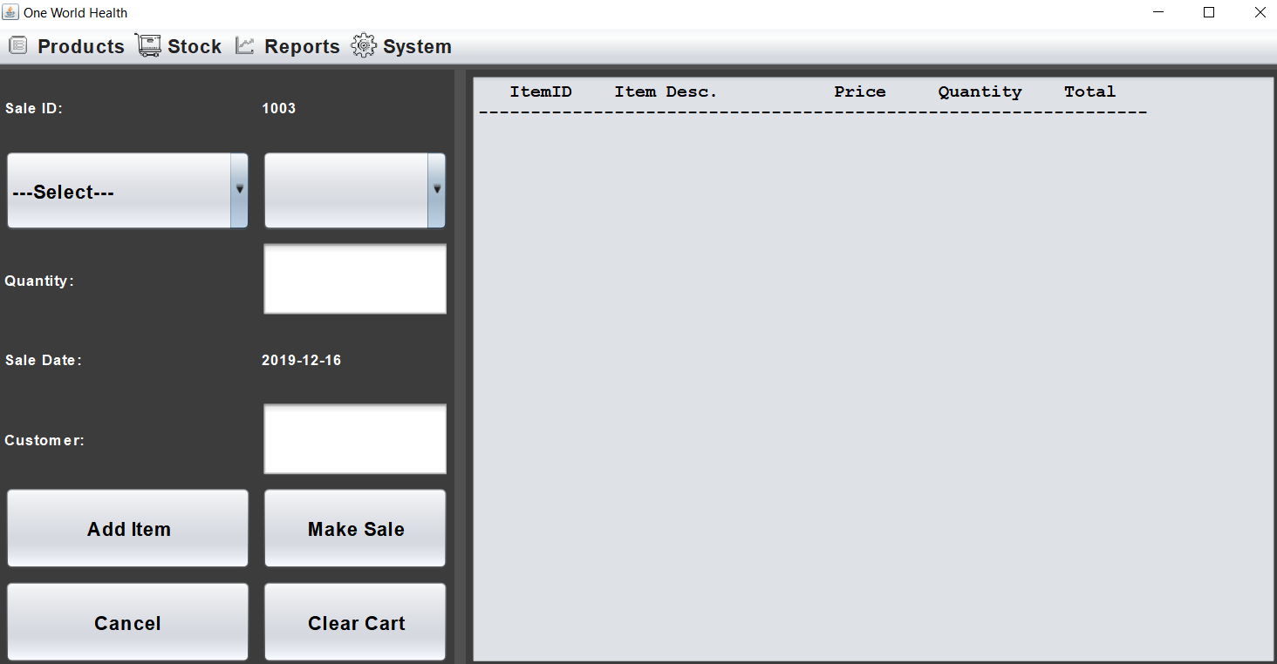

On this screen the user can make a sale by adding items to the basket. This can be done by selecting a product category from the combo box on the left, when a category is selected, all the products in that category will fill into the combo box on the right. The user must then select a product and enter a quantity and customer name. When this is done, they can add the item to the basket by clicking add item, if the input is invalid, an error message will be displayed like the example below:

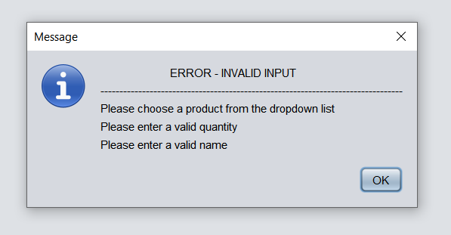

When the user adds an item to the basket, the item along with the quantity and other details of the item will be displayed in the text area to the right, this includes the total price of each item multiplied by the quantity of each item. They user can also clear the basket by clocking the clear cart button. This will remove all items from the sale and remove their details from the text area on the right-hand side. If you user clicks cancel, it will remove all items from the cart and return to the default screen which is the blank menu screen with the menu bar.

If the user clicks on the make sale button and there are items in the basket, it will show a sale completed popup and reset the sale screen so the user can make another sale if they want to. The sale completed popup is shown below:

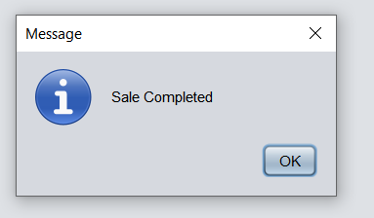

When the low stock option is selected from the report’s menu item, all items that fall below a stock level minimum of 10 are displayed. An example of this is shown below:

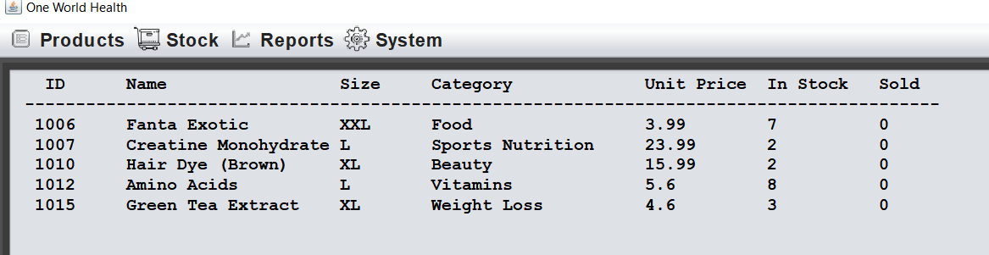

When the products by category option is selected from the report’s menu item, all stock is listed by their category. When the user clicks on the All Sales option, it will show all sales that have been made on the system as well as the relevant details of each sale. When each report option is clicked, a report will also be generated a written out to a text file. An example of the sales report screen after clicking the All Sales option is shown below:

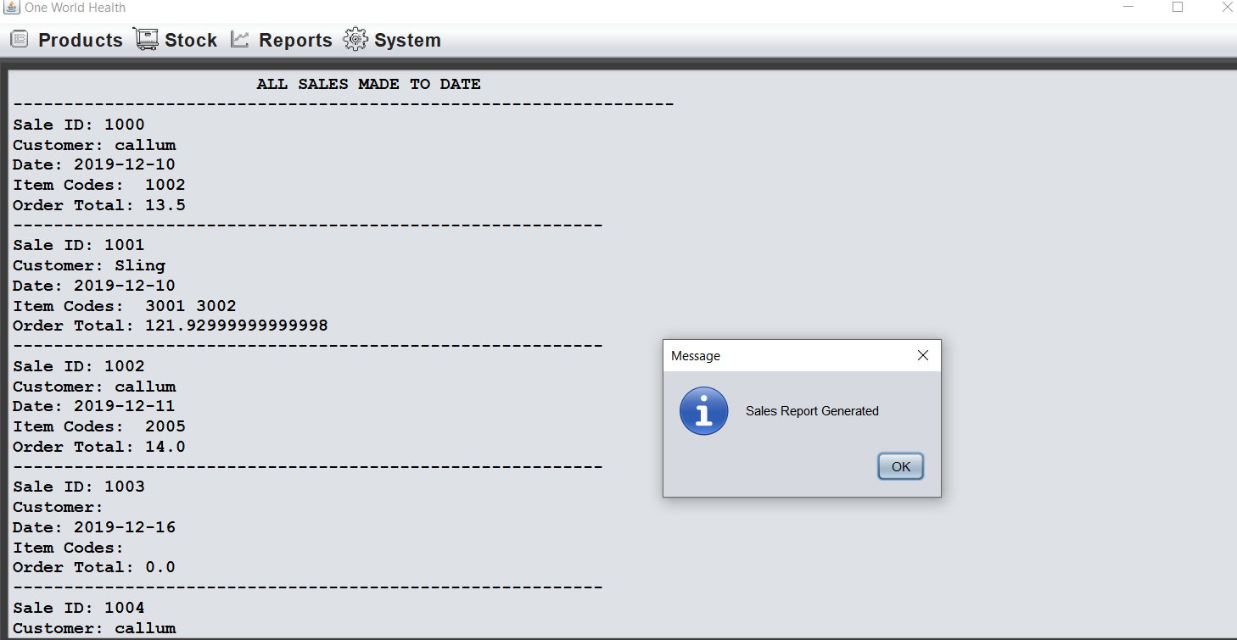

If the user clicks on the exit option on the System menu item, the user will be presented with a conformation dialog asking them if they are sure they want to exit the programme. If the user clicks yes, the system will close, if not the popup will close and the user will return to the screen they were on without anything else being changed.

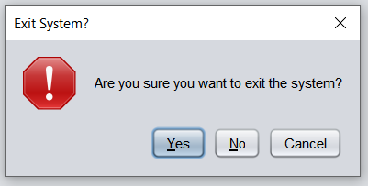

When the user exits the system, the information that was entered when the programme was running will be saved as it is written out to a file and read back in upon opening, so any information entered is saved.

N.B Do not use the main form exit button as it will not write to file upon close and whether you click yes, no or cancel it will still close the programme but will not write to file. I have no been able to fix the error.